Qn:Develop a PHP program to connect to a database and retrieve data from a table and show the details in a neat format

------------------------------------------------------------------------------------------------------------------------------------------

<!DOCTYPE html>

<html>

<body>

<?php

$servername = "localhost";

$username = "root";

$password = "";

$dbname = "phplab";

// Create connection

$conn = new mysqli($servername, $username, $password, $dbname);

// Check connection

if ($conn->connect_error) {

die("Connection failed: " . $conn->connect_error);

}

$sql = "SELECT * FROM `table2`";

$result = $conn->query($sql);

if ($result->num_rows > 0) {

echo "<table border='1'>

<tr>

<th>Id</th>

<th>Name</th>

<th>Conatct</th>

</tr>";

while($row = mysqli_fetch_array($result))

{

echo "<tr>";

echo "<td>" . $row['roll'] . "</td>";

echo "<td>" . $row['name'] . "</td>";

echo "<td>" . $row['contact'] . "</td>";

echo "</tr>";

}

echo "</table>";

}

?>

</body>

</html>

Database

---------------

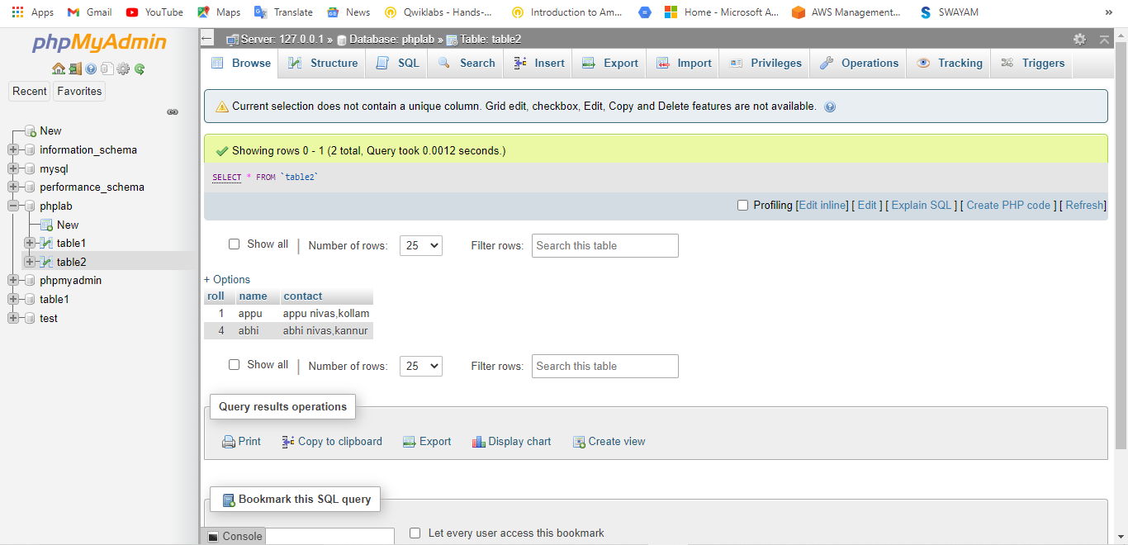

Output

----------

